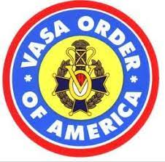 **VASA ORDER OF AMERICA**

*A Swedish American Fraternal Organization*

**DISTRICT LODGE PACIFIC SOUTHWEST No. 15**

*Instituted June 14, 1914*

[www.VasaDL15.org](http://www.VasaDL15.org)

**Vocational/Trade School Studies Scholarships**

**Championing the Future of Local Trades People**

Open to high school seniors or any qualified member who plans to or are already enrolled full- or part-time at an accredited vocational, technical, trade institution or community college.

NEW ADDITION TO THIS SCHOLARSHIP

You can use part of the award for essential required tools, equipment & supplies to learn and

be reimbursed upon submitting a specified required list from the school & receipts.

Application due date is December 06, 2025

Download application on District 15 website: [www.vasaDL15.org](http://www.vasaDL15.org)